London House Prices Prediction Report

Summary
This report presents an estimation model designed to predict London house prices in 2019, providing insightful information to support profitable investment decisions. The dataset was thoroughly examined to determine the main factors affecting real estate values and the relationships between them. Subsequently, multiple regression models were developed, optimized to achieve minimal RMSE, and further refined through stacking techniques to enhance predictive accuracy. Among all models tested, the stacked model—comprising Linear Regression, Decision Tree, GBM, and Random Forest—achieved the lowest RMSE of 3000 and an adjusted R² of 79% when validated with out-of-sample data. Based on the model’s outcomes, a prioritized list of the top 200 properties is recommended for investment to maximize profitability.

Introduction
The London housing market has changed dramatically since 1995, with average house prices soaring from £79,000 to £514,097, a roughly 600% rise. Wages increased by only 113% during the same period, from £22,487 to £48,023. This discrepancy has made homeownership out of reach for many Londoners, with roughly a third opting for long-term renting, up from 15% in 1995. First-time buyers now face enormous obstacles, with average deposits growing tenfold to £96,000 and mortgages jumping dramatically from £55,575 to £174,000.
In addition to these problems, market uncertainties such as Brexit and post-COVID inflation have added complexity. Fears of lower investment and job relocations have been offset by a weaker pound, which attracts international purchasers, while government initiatives such as the 3% stamp duty levy try to slow home price growth.
This project aims to address these issues by using machine learning algorithms to forecast home prices and discover profitable investment possibilities in the London real estate market. The purpose of developing and refining predictive models is to deliver actionable insights that maximize returns while also navigating the complexity of this dynamic market.

Body

Data Visualisation
From the data dictionary available, a few variables are analysed with the corresponding price to see any relations.
- Price over Month
London's average property prices fluctuated significantly in 2019, with noteworthy peaks and troughs throughout the year. The greatest average price was reported in July, above £620,000, while the lowest was in March, around £560,000. Interestingly, these fluctuations did not follow a steady rising or decreasing trend, but rather exhibited irregular movements, illustrating the dynamic nature of the housing market as influenced by seasonal, economic, and market-specific variables.
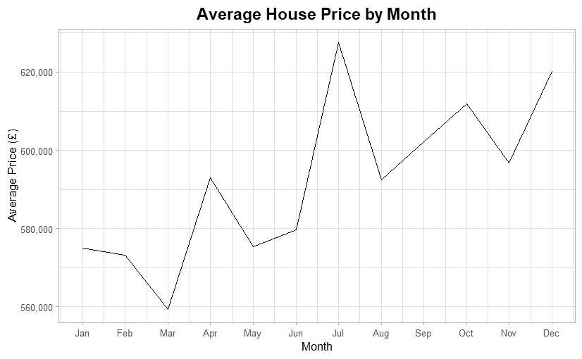
- Average Price according to the Property Type
The graph clearly shows that the average price of older houses remained continuously higher than that of new houses in 2019, with generally stable trends and little variations. In contrast, the average price of new homes was very volatile, with significant peaks and troughs seen throughout the year.
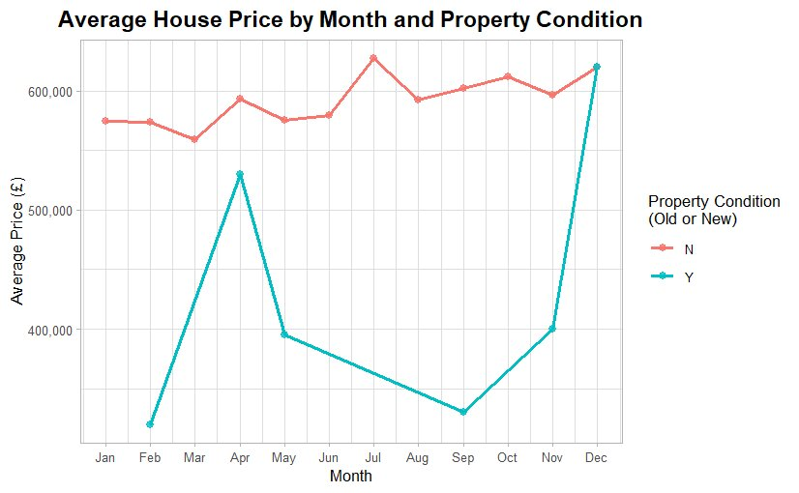

- Average Price vs District
The price of a property is heavily influenced by the district in which it is located. Among all the districts, the following graph highlights the top 20 with the highest average prices. As illustrated in the graph, it is strikingly clear that the average price in Kensington and Chelsea is nearly 490% higher than in Barking and Dagenham. This stark contrast underscores the significant price disparities across different areas.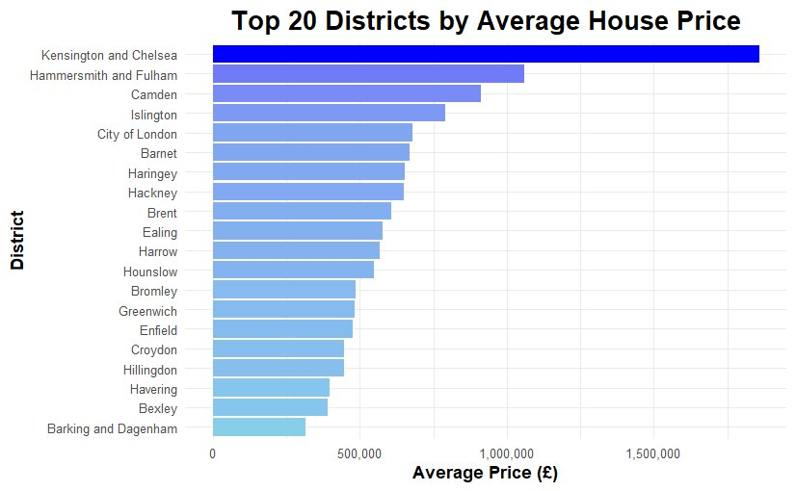
- Price vs Property
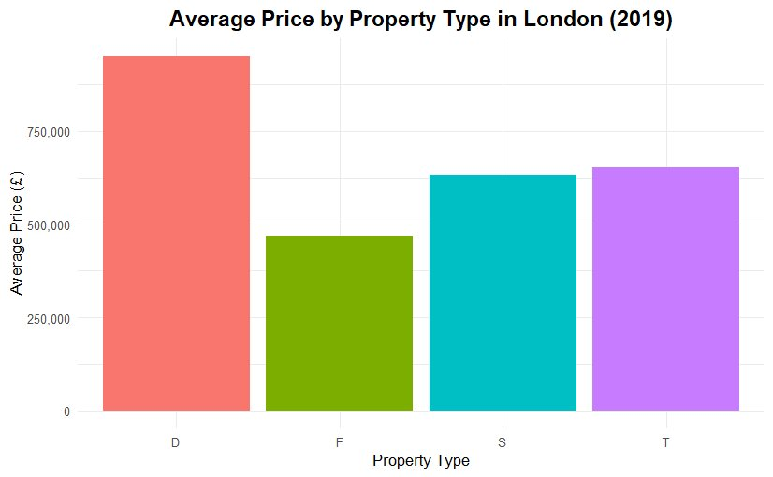
- Price vs EPC rating
The graph illustrates the relationship between EPC (Energy Performance Certificate) ratings and property prices, using a log-transformed scale for price. Higher ratings (B, C) tend to have slightly higher median prices compared to lower ratings (E, F, G). Outliers are present across all ratings, particularly for higher-priced properties, suggesting that factors beyond EPC ratings influence property prices. Overall, properties with better EPC ratings tend to be more expensive, but the relationship is not strongly linear.
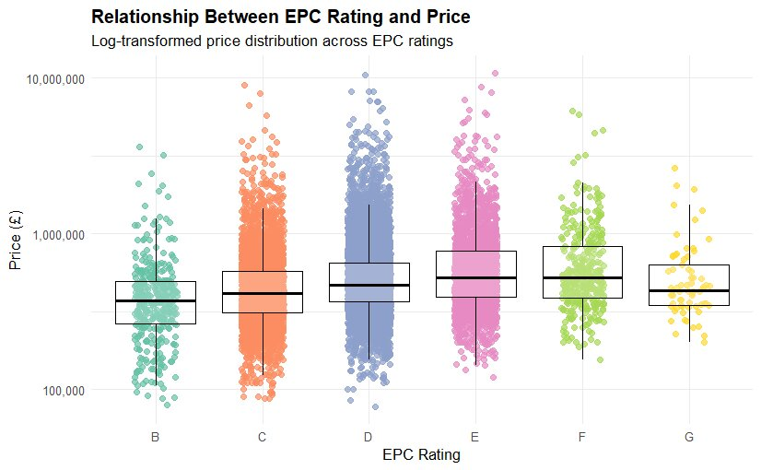
- Correlations
The correlations map below clearly reveals that several variables are closely linked to property prices. The property price shows a strong correlation with the total floor area. It is also moderately correlated with factors such as the number of habitable rooms, current and potential CO2 emissions, number of tube lines, and average income. Interestingly, the property price exhibits a negative relationship with the London zone.
Beyond the price, there are also significant correlations among other variables, particularly total floor area, number of habitable rooms, and CO2 emissions (both current and potential) and among CO2 emissions and energy_consumption (potential and current).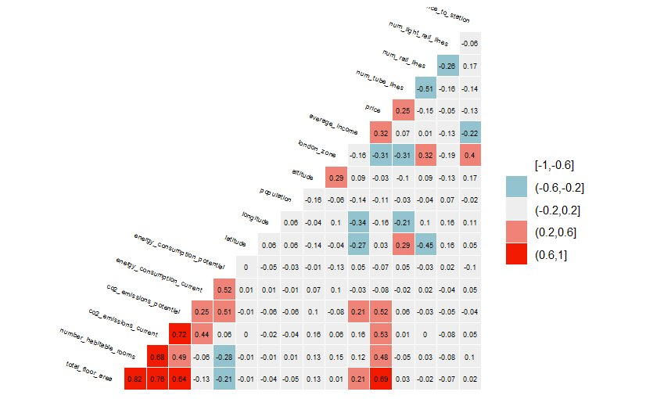

Feature Engineering
From the above visualisations, correlation map and rigorous testing, I have selected the below features to build an effective model. This selection aims to eliminate redundancy while maintaining high model performance, as measured by metrics like RMSE and adjusted R².
Features:
property_type, latitude, longitude, current_energy_rating, total_floor_area, co2_emissions_current, average_income, london_zone, num_tube_lines, windows_energy_eff, altitude, district
Interaction Variables:
average_income*london_zone: Captures the combined effect of income levels and proximity to central areas on property prices.
Important Features
Out of these, in my opinion, total_floor_area, longitude, latitude, current_energy_rating, average_income, no_tube_lines, district and london_zone are the most important ones both intuitively and as per model.
Additional Features
Apart from the variables mentioned in the data dictionary, I feel the following variables will help estimate the price of the property:
- Number of parking spaces: Affects property appeal, particularly in suburban areas.
- Property age if old: Older properties may have historical value or require higher maintenance, influencing price.
- A Boolean to indicate if any renovations are made: Could increase the value of older property if renovations are made
- Air Quality Index: Indicates the pollution levels and is an important indicator when considering a property in a region.
- Distance to amenities: Proximity to grocery stores, parks, and shopping centres often increases property value.
- Distance to hospitals: Critical for families and elderly residents, influencing their choice of residence.

Models

Linear Regression
The performance of the Linear Regression model was evaluated using two key metrics: Root Mean Squared Error (RMSE) and Adjusted R². The model was tested with both the original features and additional interaction variables.
The performance results for each model are as follows:
Model Type | RMSE | Adjusted R²
Without Interaction Variables | 425464 | 0.6169804
With Interaction Variables | 326009.6 | 0.6802904

The model that incorporated interaction variables performed better, with an improvement in Adjusted R² of 0.07.

Decision Tree
Two Decision Tree models were developed: one including interaction variables and one excluding them. Both models underwent hyperparameter tuning, where the tune length was adjusted from 8 to 15. After testing various lengths, a tune length of 12 was selected for both models as the optimal configuration.
The performance results for each model are as follows:
Model Type | RMSE | Adjusted R²
Without Interaction Variables | 301,565.7 | 0.7251
With Interaction Variables | 288,288.7 | 0.7492

The model that incorporated interaction variables performed slightly better, with an improvement in Adjusted R² of 0.02, showing a modest enhancement in predictive accuracy.

Lasso Regression
With lasso regression, below are the results:
Model Type | RMSE | Adjusted R²
Without Interaction Variables | 330020.3 | 0.6727566

Random Forest
The Random Forest performed better than the Decision Tree model as expected. The model was hypertuned using a range of values for the parameter “mtry” from 2- 5. In both the models with and without interaction variables mtry = 5, gave better R2 value.
The performance results for each model are as follows:
Model Type | RMSE | Adjusted R²
Without Interaction Variables | 283923.7 | 0.8021951
With Interaction Variables | 280767.5 | 0.804244

The model that incorporated interaction variables performed slightly better, with an improvement in Adjusted R² of 0.02, showing a modest enhancement in predictive accuracy.

Gradient Boosting Method (GBM)
The Gradient Boosting Method (GBM) outperformed other models previously built and tested, demonstrating superior predictive accuracy. A GBM model was hypertuned using a range of values for key hyperparameters, including maximum interaction depth, the number of trees, shrinkage, and the minimum observations in a leaf node.
The hyperparameter grid used for tuning was as follows:
Hyperparameter | Values Tested
interaction.depth | 3, 5, 7
n.trees | 100, 200, 300
shrinkage | 0.01, 0.03, 0.1
n.minobsinnode | 5, 10, 20
After training across these combinations, the best result was achieved with:
- n.trees = 300
- interaction.depth = 7
- shrinkage = 0.1
- n.minobsinnode = 5
To mitigate the risk of overfitting, the final model was adjusted to slightly more conservative hyperparameters:
- n.trees = 200
- interaction.depth = 5
- shrinkage = 0.1
- n.minobsinnode = 5
The models with and without interaction variables produced comparable results, both exhibiting high performance. The results are summarized below:
Model Type | RMSE | Adjusted R²
Without Interaction Variables | 213,062 | 0.8622906
With Interaction Variables | 212,262 | 0.8629728

Both the models performed similarly high with a very minute difference of 0.0007.
Stacked Model
The models developed in the analysis were combined into a stacked ensemble model, retaining their respective hyperparameters to evaluate performance comprehensively. The results are summarized below:
Model Type | RMSE | Adjusted R²
Without Interaction Variables | 226606.1 | 0.8455884
With Interaction Variables | 225004.9 | 0.8464571

The inclusion of interaction variables slightly improved the model’s performance, as reflected in a marginally lower RMSE and a higher Adjusted R² value.

Results and Selecting Investments

Final Results
Comparing all the above models, models with interaction variables give slightly better R2 values, hence the models with interaction variables are selected for final comparison.
Model | RMSE | Adj R2 value
Linear Regression | 326009.6 | 0.6802904
Decision Tree | 288,288.7 | 0.7492
Random Forest | 280767.5 | 0.804244
GBM | 212,262 | 0.8629728
Stacked | 225004.9 | 0.8464571
The stacked model is selected as the best model.

Selecting Investments
To select the top 200 investments to buy, I am predicting the price with the stacked model and adding the predicted price and the difference between the predicted price and asking price to the out-of-sample data frame. Later, the data frame is sorted in descending order of the difference and the first 200 rows are flagged buy as 1 and the remaining rows are flagged buy as 0. At last, the new data frame is written to the csv file.
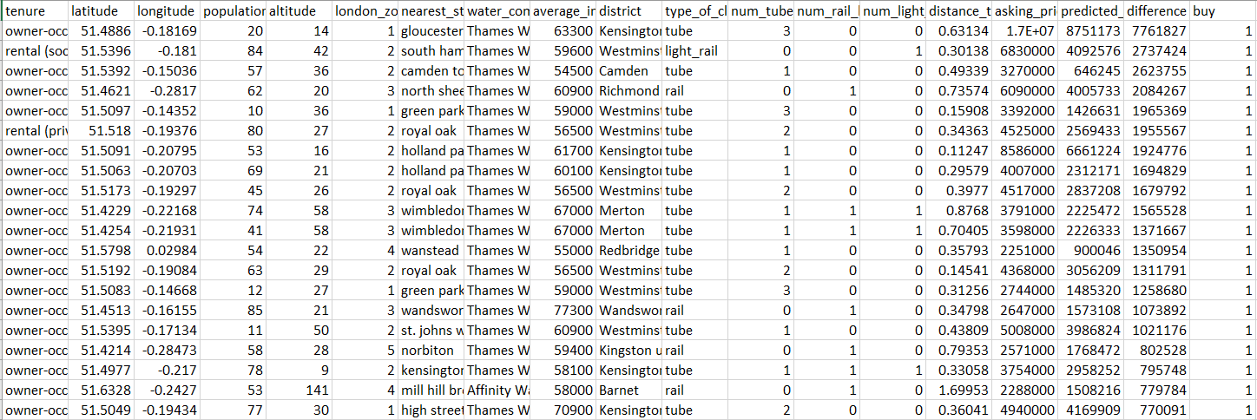
Figure: Snapshot of the output Excel file with predicted_price, difference (asking_price – predicted_price) and buy

Elizabeth Line
The Elizabeth Line is the biggest and busiest line connecting West and East London to Central London. To predict if it is worth investing in the properties closest to the Elizabeth line, the above estimation model could be used with slight changes.
The Elizabeth Line is the biggest and most transformative addition to London's transport network, connecting the west, east, and central parts of the city with unprecedented efficiency. Its impact on accessibility has significantly enhanced the appeal of neighbourhoods along its route, making these areas prime targets for real estate investment. To determine whether investing in properties near the Elizabeth Line is profitable or not, the existing estimation model can be adapted with slight changes.
Firstly, we will add a new feature the distance from the property to the nearest Elizabeth tube station to the Out of Sample dataset. Later, we will sort the data frame in the ascending order of the distance.
Secondly, a comparative profitability analysis can be conducted by calculating the difference between the asking price and the model's predicted price. Finally, we check the correlation between the price difference and the distance to the nearest Elizabeth station. If the correlation is moderately or highly negative (range of -0.5 to -1) and if properties closer to the Elizabeth Line show a positive investment profit for the majority of the cases, it indicates strong market demand and profit potential. This data could be helpful for investors in choosing which property to invest in and earn profit.
However, if the correlation is in the range of (-0.4 to 0.4), it indicates that the distance isn’t a determining factor for the investment profit. In addition, if the correlation is in the range (0.4 to 1), it indicates that as property lies far away from the tube station, the investment profit increases. In both these cases, we can warn the investors that buying properties closer to Elizabeth incurs loss.

